
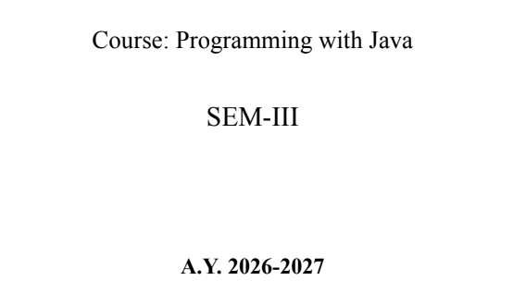
NAME: BHOOMI VIJAYVARGIYA
BATCH: A2
PRN: 25070122062
ASSIGNMENT-9
TITLE : Write a Java program to demonstrate the use of the final keyword with variables, methods, and classes.
Problem Statement Write a Java program to demonstrate the use of the final keyword with variables, methods, and classes.
Learning Objectives: To implement the final keyword with variables, methods, and classes.
Theory
The final keyword restricts modification in Java programs. A final variable cannot be reassigned after initialization. A final method cannot be overridden by subclasses, while a final class cannot be inherited. This improves security, prevents accidental modifications, and increases program reliability. Final is commonly used for constants and immutable classes.
Code:
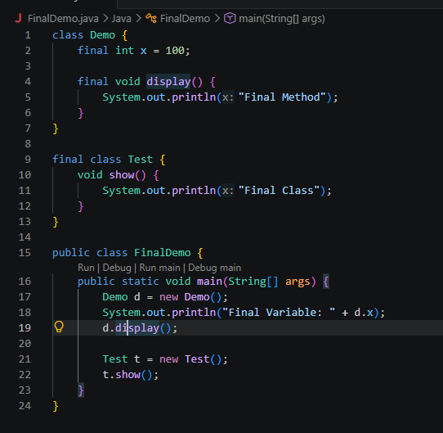
Output:
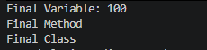
Conclusion:
The program was implemented and executed successfully. It demonstrated the required Java concept and produced the expected results, improving understanding of object-oriented programming and Java programming concepts.
These are suitable for most Java lab experiments, including programs on classes, inheritance, interfaces, packages, exceptions, collections, final, multithreading, and file handling.

Exercise
- Create a Bank Account program where account number is final and cannot be changed.
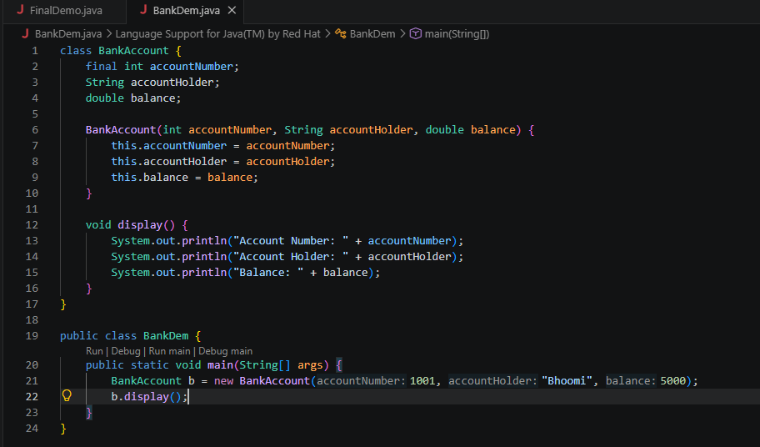
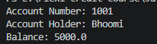
- Create a Library Book Management program where the book ISBN is declared as final and cannot be changed once assigned. Display the book's ISBN, title, author, and price.
